**File Permissions and Ownership in Linux**

In Linux, file permissions and ownership are essential for ensuring security and proper access control. Each file and directory have associated permissions that dictate who can read, write, and execute them. These permissions are divided into three categories:

* Owner: The user who owns the file.
* Group: A group of users who share the same permissions.
* Others: All other users who have access to the system.

To view the permissions of a file, you can use the ls -ltr command:

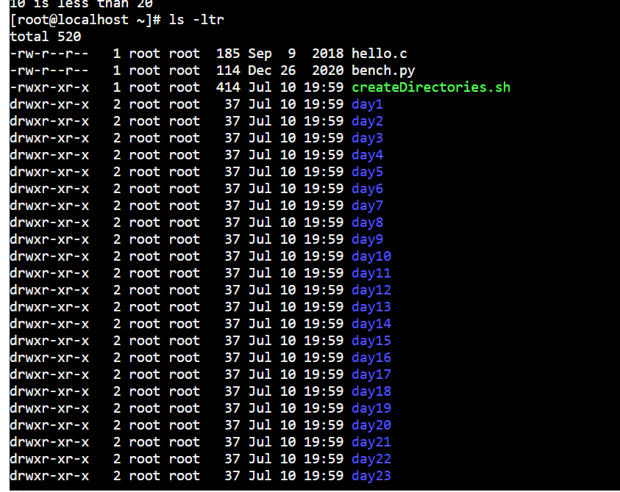

**Changing Ownership and Permissions**

To change the ownership

chown rimsha myfile.txt

For change the permission

chmod 755 myfile.txt

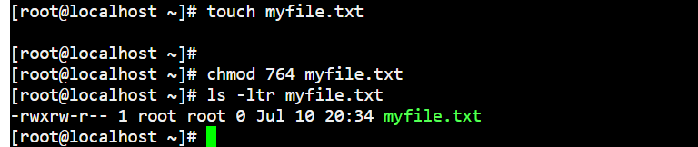

**Access Control Lists (ACLs)**

getfacl myfile.txt

setfacl -m u:john:rwx myfile.txt

Understanding and managing file permissions and ownership is crucial in Linux to maintain security and control access. By using commands like chown, chgrp, and chmod, you can modify permissions and ownership as needed. ACLs provide additional flexibility for setting permissions on a per-user or per-group basis.